Weak skill :-3
Task :-1
#include <stdio.h>
#include <stdlib.h>
#include <string.h>

int main()
{
char command[100];

while (1)
{
// Display prompt
printf("OSSP> ");
fflush(stdout);

// Read user input
if (fgets(command, sizeof(command), stdin) == NULL)
{
printf("\n");
break;
}

// Remove newline character
command[strcspn(command, "\n")] = '\0';

// Handle empty input
if (strlen(command) == 0)
{
continue;
}

// Handle exit condition
if (strcmp(command, "exit") == 0)
{
printf("Exiting shell...\n");
break;
}

// Display entered command
printf("You entered: %s\n", command);
}

return 0;
}
Output:-
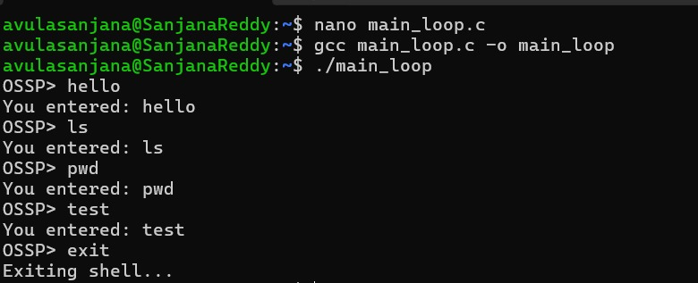

Task:-2
#include <stdio.h>
#include <fcntl.h>
#include <unistd.h>
#include <stdlib.h>

int main()
{
int fd1, fd2;
char buffer[100];
ssize_t n;

// Open File1.txt for reading
fd1 = open("File1.txt", O_RDONLY);

if (fd1 < 0)
{
perror("Error opening File1.txt");
return 1;
}

// Open File2.txt for writing
// Create it if it does not exist
// Truncate it if it already exists
fd2 = open("File2.txt", O_CREAT | O_WRONLY | O_TRUNC, 0644);

if (fd2 < 0)
{
perror("Error opening File2.txt");
close(fd1);
return 1;
}

// Read from File1.txt and write to File2.txt
while ((n = read(fd1, buffer, sizeof(buffer))) > 0)
{
if (write(fd2, buffer, n) != n)
{
perror("Error writing to File2.txt");
close(fd1);
close(fd2);
return 1;
}
}

if (n < 0)
{
perror("Error reading File1.txt");
}
else
{
printf("File copied successfully!\n");
}

// Close both files
close(fd1);
close(fd2);

return 0;
}
Output:-
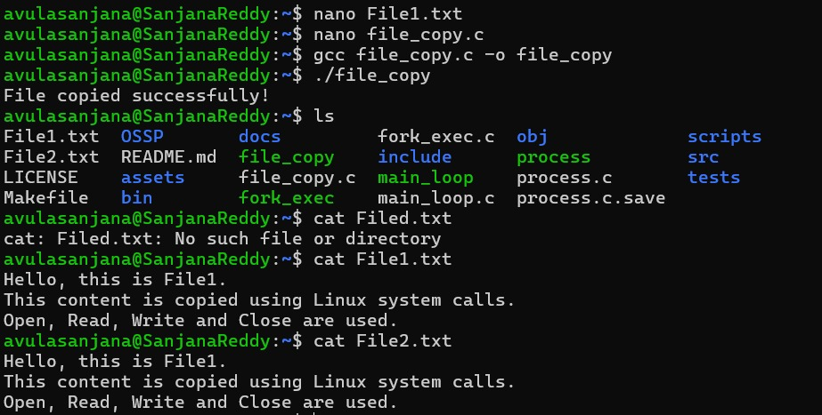
Task :-3
#include <stdio.h>
#include <string.h>

#define MAX 100

int main()
{
char buffer[MAX];
int index = 0;
char ch;

printf("Simple Keyboard Input Program\n");
printf("Type a command (type 'exit' to quit)\n");

while (1)
{
printf("OSSP> ");
index = 0;

while (1)
{
ch = getchar();

// Enter key
if (ch == '\n')
{
buffer[index] = '\0';
break;
}

// Backspace key
else if (ch == 127 || ch == '\b')
{
if (index > 0)
{
index--;
printf("\b \b");
}
}

// Store normal characters
else
{
if (index < MAX - 1)
{
buffer[index++] = ch;
}
}
}

if (strcmp(buffer, "exit") == 0)
{
printf("Exiting Program...\n");
break;
}

printf("Command Entered: %s\n", buffer);
}

return 0;
}
Output:-
